Chapter 5
A Closed-Economy One-Period
Macroeconomic Model

n Teaching Goals
There are three key points to be learned from this chapter. The first point is that when we allow the consumers and firms that we studied in Chapter 4 to interact with each other and with the government,
the economy is able to achieve equilibrium through price adjustment. In this particular case, the “price” is the relative price of leisure, the real wage. The second important point is that the equilibrium that markets settle upon is a favorable one, in the sense of Pareto optimality. This point is in keeping with Adam Smith’s notion that the “invisible hand” of self-interested individuals, meeting in a competitive market, can work for the common good. The third point is that we can directly discover the equilibrium position
of a market economy by solving an economic planner problem. Although students may find this point to be somewhat arcane, stress the point that it will be much simpler to solve problems (e.g., exam problems) by working with a planner problem as opposed to directly solving general equilibrium problems. The students, however, need to be aware when this solution method is not applicable. The section about the Laffer curve is a good way to show when social and private optima do not coincide.
Once students have mastered the mechanics of the model, the two problems for which this model is best suited are the analyses of changes in government spending and total factor productivity. In working these problems, stress the applicability of these results to historical applications and as a guide to understanding current events.
A key tactic of the textbook’s approach is the critical assessment of the usefulness and credibility of competing models. Therefore, it is important to stress the extent to which models fit the facts. Does this model fit the facts of long-run growth? Does this model fit the facts of the typical business cycle? These kinds of questions come up again and again in the course of macroeconomic study. Stress again and again that scientific study needs to relate to observations, in our case the stylized facts of Chapter 2.

n Classroom Discussion Topics
An alternative approach to this material is to start with the example of Robinson Crusoe (or Castaway, Gilligan’s Island, etc.). Does an isolated individual have any economic choices? What would guide these choices? Would you rather be on an island with a more plentiful food supply? A pure income effect can then be presented in the form of extra food (or a volleyball) washing up on shore, or in the form of “pirates” (government?) demanding tribute. An increase in total factor productivity can be in the form of obtaining a fishing net or a ladder to climb coconut trees. A change in capital can be the consequence of a hurricane, etc.
The next step would be to ask the students about the likely consequences of additional individuals on the island. If they are all identical, and there are no economies to team production, will there be any reason for markets to exist? Could a market improve things? How and why? Typically, markets improve things only to the extent that people are different. However, these types of differences are what we are willing to ignore when we adopt the fiction of a representative consumer.

n Outline
I. Competitive Equilibrium
A. A One-Period Model
1. No Borrowing or Lending
2. G = T
B. Equilibrium Modeling
1. Endogenous Variables
2. Exogenous Variables
3. Hypothetical Experiments
C. Properties of a Competitive Equilibrium
1. Representative Consumer Maximizes Utility Subject to Budget Constraint
2. Representative Firm Maximizes Profits
3. Markets Clear
4. Government Budget Constraint Satisfied
5. 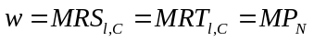
II. Optimality
A. Pareto Optimality
B. Welfare Theorems
1. 1st Theorem: A Competitive Equilibrium Can Be Pareto Optimal
2. 2nd Theorem: A Pareto Optimum Can Be a Competitive Equilibrium
C. Inefficiencies
1. Externalities
2. Distorting Taxes
3. Monopoly Power
D. Using the Second Theorem
1. Pareto Optima Are Easier to Identify
2. Effects of Disturbances on Pareto Optima
III. Effects of an Increase in Government Spending
A. Impact Effect
1. Parallel Downward Shift in PPF
2. Pure Income Effect
B. Equilibrium Effects
1. Reduced Consumption
2. Reduced Leisure and Increased Hours of Work
3. Increased Output
4. Lower Real Wage
C. Crowding-Out
D. Government Spending a Source of Business Cycles?
1. Government Spending Shocks Wrongly Predict Countercyclical Consumption
2. Government Spending Shocks Wrongly Predict Countercyclical Real Wages

IV. Effects of an Increase in Total Factor Productivity
A. Impact Effect
1. Upward Shift in PPF
2. Steeper PPF
3. Income and Substitution Effects
B. Equilibrium Effects
1. Increased Consumption
2. Leisure and Hours Worked May Rise or Fall
3. Increased Output
4. Higher Real Wage
C. Productivity and Long-Run Growth
1. Consumption Grows over Time
2. Hours Worked Remain about Constant
3. Output Increases over Time
4. Real Wages Rise over Time
D. Productivity as Source of Business Cycles?
1. Consumption Is Procyclical
2. Cyclical Properties of Hours Worked
a. Procyclical Hours Worked Is a Business Cycle Fact
b. Need Strong Substitution Effect to Predict Procyclical Hours
c. Intertemporal Substitution of Leisure
3. Increased Output Defines the Cycle
4. Procyclical Real Wage Rate
V. Income Tax Revenue and the Laffer Curve
A. Tax Revenue
1. The Tax Base Depends on the Proportional Tax Rate
2. The Laffer Curve Measures Tax Revenue as a Function of the Tax Rate
3. Unless the Tax Rate Is Optimal, Two Tax Rates Yield the Same Tax Revenue
4. Supply-Side Economists Claim the U.S. Economy Is at the Bad Tax Rate
5. Empirical Evidence Tends to Prove Supply-Side Economists Wrong

VI. A Model of Public Goods: How Large Should the Government Be?

A. Effects of higher GDP on optimal government spending.

B. Better government technology: what happens to optimal government spending and private
spending?

n Learning Objectives
- Define and construct a competitive equilibrium for the closed-economy one-period macroeconomic (CEOP) model.
- Show that the competitive equilibrium and the Pareto optimum for the CEOP model are the same thing.
- Analyze and interpret the effects of changes in exogenous variables in the CEOP model.
- Decompose the effects of an increase in total factor productivity in the CEOP model into income and substitution effects.
- Analyze the effects of a distorting labor income tax in the simplified CEOP model.
- Analyze the determinants of the size of government and private consumption.

n Solutions to End-of-Chapter Problems

1. In a one period model, taxes must be equal to government spending. A reduction in taxes is therefore equivalent to a reduction in government spending. The result is exactly opposite of the case of an increase in government spending that is presented in the text. A reduction in government spending induces a pure income effect that induces the consumer to consume more and work less. At lower employment, the equilibrium real wage is higher because the marginal product of labor rises when employment falls. Output falls, consumption rises, employment falls and the real wage rises.

2. The only impact effect of this disturbance is to lower the capital stock. Therefore, the production possibility frontier shifts down and the marginal product of labor falls (PPF is flatter).

(a) The reduction in the capital stock is depicted in the figure that follows. The economy starts at point A on PPF₁. The reduction in the capital stock shifts the production possibilities frontier to PPF₂. Because PPF₂ is flatter, there is a substitution effect that moves the consumer to point D. The consumer consumes less of the consumption good and consumes more leisure. Less leisure also means that the consumer works more. Because the production possibilities frontier shifts down, there is also an income effect. The income effect implies less consumption and less leisure (more work). On net, consumption must fall, but leisure could decrease, remain the same, or increase, depending on the relative strengths of the income and substitution effect. The real wage must also fall. To see this, we must remember that, in equilibrium, the real wage must equal the marginal rate of substitution. The substitution effect implies a lower marginal rate of substitution. The income effect is a parallel shift in the production possibilities frontier. As the income effect increases the amount of employment, marginal product of labor must fall from point D to
point B. This reinforces the reduction in the marginal rate of substitution from point A to point D.

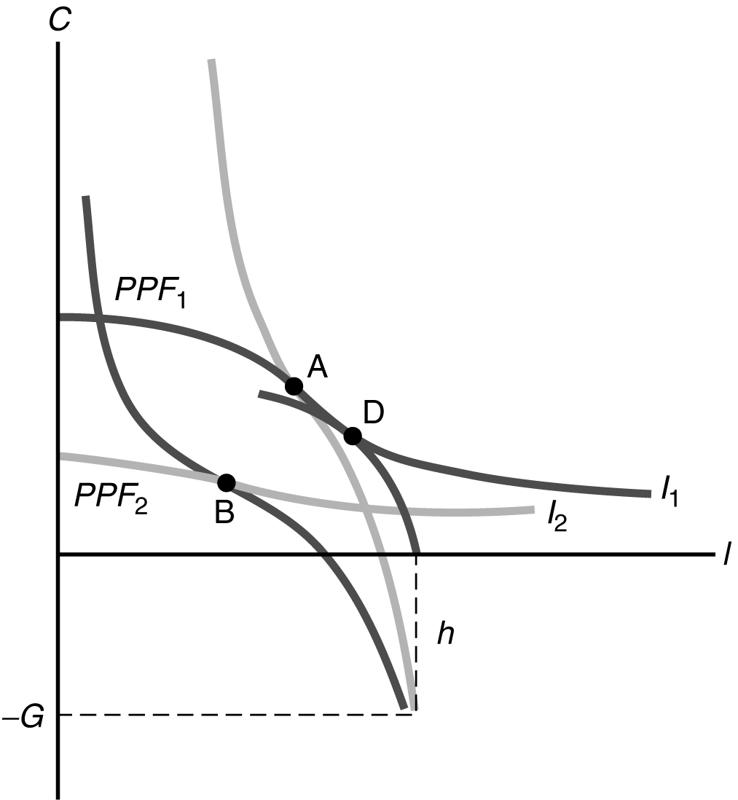

(b) Changes in the capital stock are not likely candidates for the source of the typical business cycle. While it is easy to construct examples of precipitous declines in capital, it is more difficult to imagine sudden increases in the capital stock. The capital stock usually trends upward, and this upward trend is important for economic growth. However, the amount of new capital generated by a higher level of investment over the course of a few quarters, of a few years, is very small in comparison to the existing stock of capital. On the other hand, a natural disaster that decreases the stock of capital implies lower output and consumption, and also implies lower real wages, which are all features of the typical business cycle contraction.

3. Government Productivity. First consider the benchmark case in which 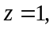 and there is no effect of changes in z on government activities. Now suppose that z increases. This case of an increase in z is depicted in the figure that follows. The original production possibilities frontier is labeled PPF₁ and the competitive equilibrium is at point A. If the increase in z only affects the economy through the change in 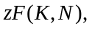 then the new production possibilities frontier is PPF₂. The diagram shows a case in which the income and substitution effects on leisure exactly cancel out, and the economy moves to point B. The equation for the production possibilities frontier is 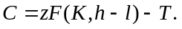 In the benchmark case, 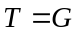 and so we have 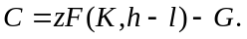 For this problem, 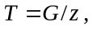 and so the production possibilities frontier is given by 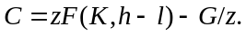 When the two PPFs coincide. When z increases, the vertical intercept of the PPF increases by 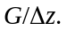 Therefore, the new PPF is PPF₃ in the figure that follows. The competitive equilibrium is at point C. There is an additional income effect that provides an additional increase in equilibrium consumption, and a reinforced income effect that tend to make leisure increase. Therefore, relative to the benchmark case, there is a larger increase in consumption, and either a smaller decrease in leisure or a larger increase in leisure.

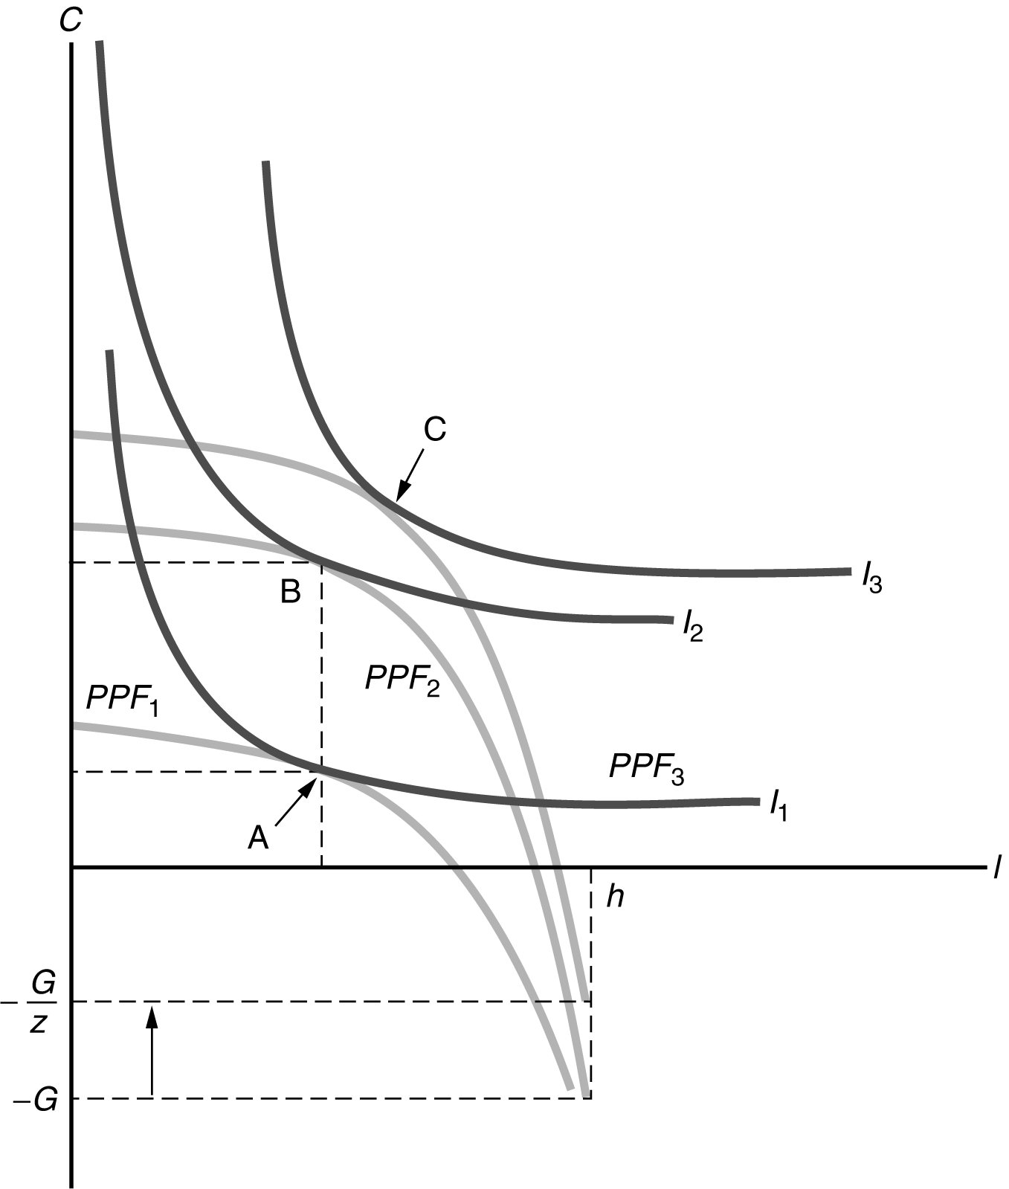

4. Change in preferences.

(a) At the margin, the consumer decides that leisure is more preferred to consumption. That is, the consumer now requires a bigger increase in consumption to willingly work more (consume less leisure). In more intuitive language, the consumer is lazier.

(b) To work out the effects of this change in tastes, we refer to the figure that follows. The production possibility frontier in this example is unchanged. The consumer now picks a new point at which one of the flatter indifference curves is tangent to the production possibilities frontier. That is, equilibrium will shift from point A to point B. Consumption falls and leisure rises. Therefore, the consumer works less and produces less. Because employment has fallen, it also must be the case that the real wage increases.

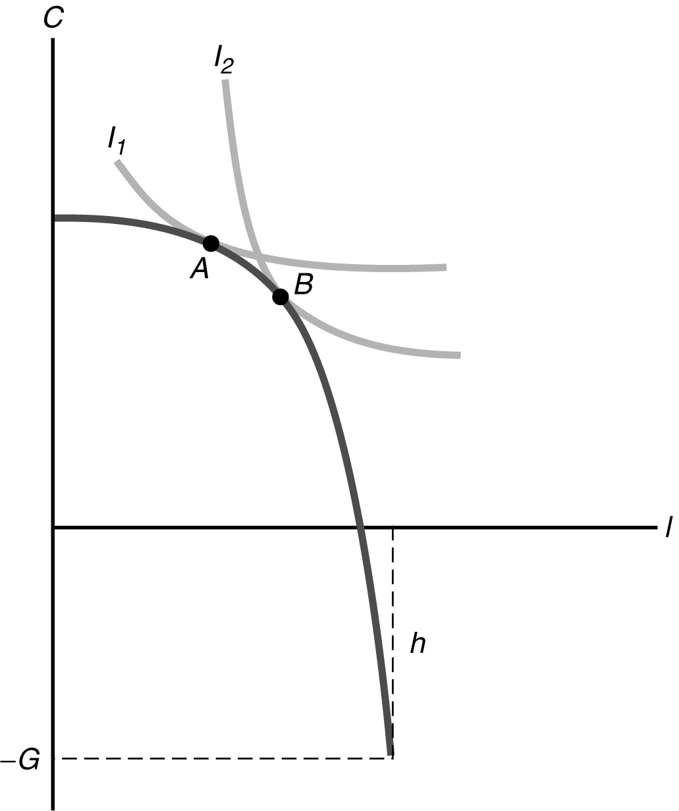

(c) This disturbance, which some might characterize as a contagious outbreak of laziness, would have the appearance of a recession, as output and employment both fall. The consequent reduction in consumption is also consistent with a typical recession. However, in this case the real wage would rise, which is inconsistent with the business cycle facts. Therefore, this type of preference change is not a cause of recessions.

5. Production-enhancing aspects of government spending.

(a) The increase in government spending in this example has two separate effects on the production possibilities frontier. First, the increase in government spending from G₁ to G₂ implies a parallel downward shift in the production possibilities frontier. Second, the productive nature of government spending is equivalent to an increase in total factor productivity that shifts the production possibilities frontier upward and increases its slope. The figure that follows draws the original production possibilities frontier as PPF₁ and the new production possibilities frontier as PPF₂. If the production-enhancing aspects of the increase in government spending are large enough, representative consumer utility could rise, as in this figure.

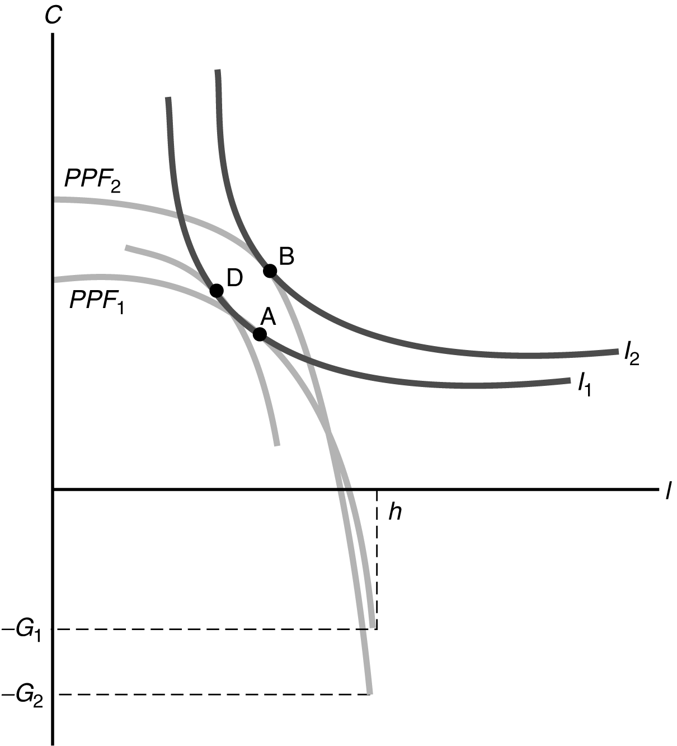

(b) There are three effects at work in this example. First, there is a negative income effect from the increase in taxes needed to pay for the increased government spending. This effect tends to lower both consumption and leisure. Second, there is a substitution effect due to the productive effect of the increase in G, which is drawn as the movement from point A to point D. This effect tends to increase both consumption and leisure. Third, there is a positive income effect from the increase in G on productivity. This effect tends to increase both consumption and leisure. In the figure above, the movement from point D to point B is the net effect of the two income effects. In general, consumption may rise or fall, and leisure may rise or fall. The overall effect on output is the same as in any increase in total factor productivity. Output surely rises.

6. (a) If households dedicate a hours to education today, it reduces the hours available for leisure and work to h − a. The PPF has to start from point (−G, h − a). Graphically, this corresponds to the figure in the answer of question 6(b). The consequence is thus a reduction in consumption, leisure, employment, and aggregate output, but an increase in the real wage.

(b) In the future, workers will be more efficient, which corresponds to an increase in total factor productivity. Thus we have the case described in Figure 5.9 of the textbook. There is an increase in future consumption, aggregate output and the real wage. Changes in employment and leisure are ambiguous.

(c) An increase in education leads to an immediate loss in welfare, as both leisure and consumption are reduced. But this is compensated by an increase in future consumption, and possibly of leisure, too. Whether this is worth doing depends on the preferences of households over current and future utility.

7. Let p denote the quantity of pollution produced. Given the problem, we can say that p = aY, where a > 0. A convenient assumption is that pollution reduces the effective amount of consumption one-for-one, so a consumer’s effective amount of consumption is C-p. When the representative consumer is optimizing, then MRS_{l,C} = w, and optimization by the representative firm implies MP_{N} = w, so in equilibrium MRS_{l,C} = MP_{N}. But, from the fictitious planner’s point of view, the marginal rate of transformation of leisure for effective consumption is actually MP_{N}(1-a), since at the aggregate level, one unit of extra labor produces one unit of consumption and a units of pollution. So, for the social planner, the Pareto optimum is characterized by MRS_{l,C} = MP_{N}(1-a) or, equivalently, MRS_{l,C}/(1-a) = MP_{N}. So, clearly, the competitive equilibrium and the Pareto optimum are not the same thing in this case, with an externality. To illustrate this in terms of consumption and leisure (and recall that G=T=0 in this problem):

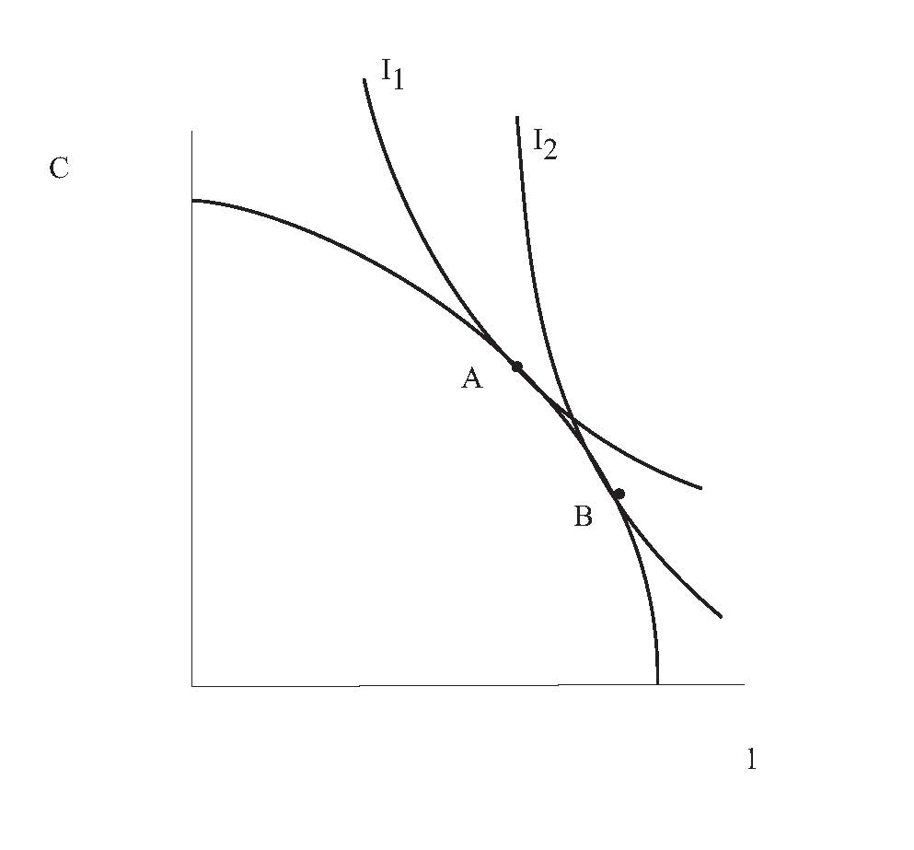

In the figure, point A is the competitive equilibrium while point B is the Pareto optimum. I₁ is the indifference curve of the consumer from his or her point of view, and I₂ is the indifference curve the social planner sees the consumer having, taking the pollution externality into account. Note that in the competitive equilibrium there is too much consumption and too little leisure, relative to the Pareto optimum. For part (b), if the government imposes a tax t = a, on the production of goods by the firm, then this will imply that the competitive equilibrium is Pareto optimal. This is a “Pigouvian tax,” which corrects the negative externality.

8. We need to analyze each case separately. Start with the good equilibrium. As government expenses increase, more tax revenue needs to be raised, and thus the tax rate needs to be increased. As shown in the figure that follows, this tilts down the linear PPF. The new equilibrium leads to a lower indifference curve. This leads to a negative income effect and a lower wage (remember, it is z(1 − t)), thus a substitution effect. The income effect lowers consumption and leisure, the substitution effect decreases consumption and increases leisure. All in all, consumption is lower and leisure is higher, as we know that the substitution effect dominates the income effect. This means that the labor supply is reduced, and thus equilibrium labor and output.

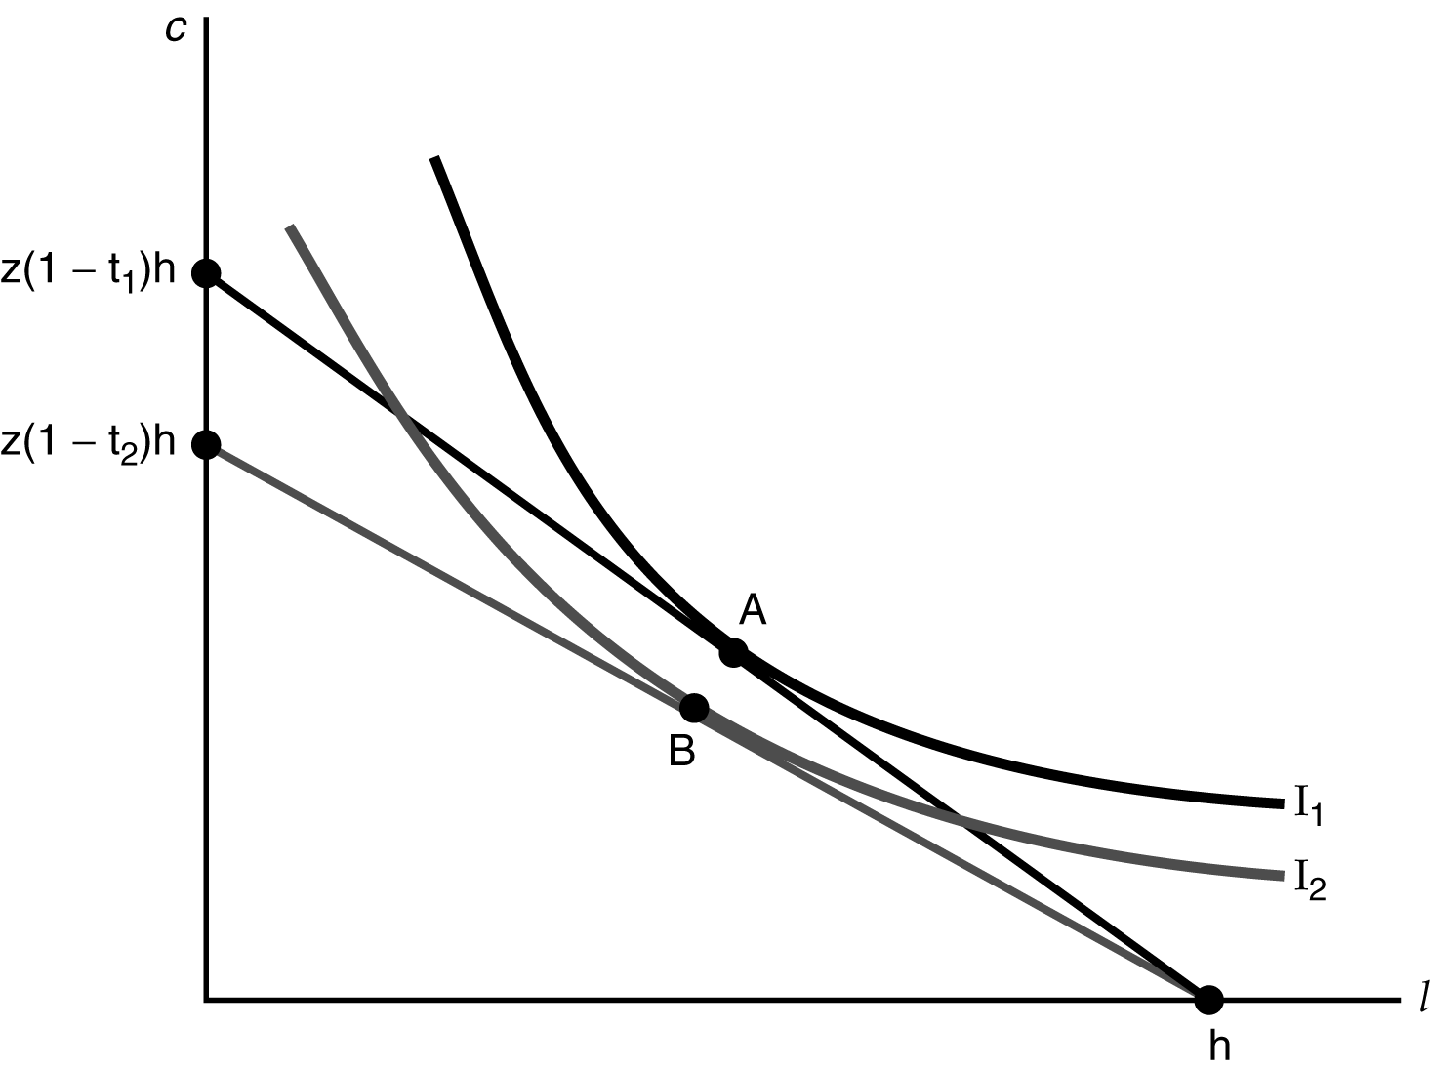

The story is different in the bad equilibrium. To increase tax revenue, one needs to reduce the tax rate. Then all the changes discussed above are exactly in the opposite direction.

9. We know from previous analysis that an improvement in total factor productivity pushes up the PPF, and thus leads to an increase in consumption, a decrease in leisure, and thus an increase in the quantity of labor supplied. This increases the tax base, and thus allows a reduced tax rate to achieve the same tax revenue, or in other words, it pushes the left portion of the Laffer curve to the left. The reduction in the tax rate has then a further impact on the variables of interest: as we saw in question 7, first part with a reversal of all signs: consumption increases even more and leisure decrease yet more, leading to an even higher quantity of labor. All in all, as both labor and total factor productivity increase, output increases.

10. a) With perfect substitutes preferences, indifference curves are straight lines with slope –b, where b is
the marginal rate of substitution. If b > 1/q, so that the indifference curves are steeper than the PPF, then the optimal choice for the government is G=qY, so that C = 0. Thus if b is relatively large (the consumer cares relatively more about public goods relative to private goods) and q is relatively large (the government is relatively efficient), then all production should be carried on by the government. Alternatively if b < 1/q, then G = 0 and C = Y, so that government is inactive. Thus, if b increases or q increases, this makes it more likely that b > 1/q and we have the first case, where all production comes from the government.

b) With perfect complements, indifference curves are as depicted in Figure 10.1, and the initial equilibrium is at point A. If a increases, then the equilibrium shifts from A to B in Figure 10.2. An increase in a represents a greater preference for private goods relative to public goods, and in Figure 10.2, this results in less public goods and more private consumption in equilibrium. If q increases, this shifts the PPF out as in Figure 10.3, and the equilibrium shifts from A to B. Both C and G increase, driven by income effects.

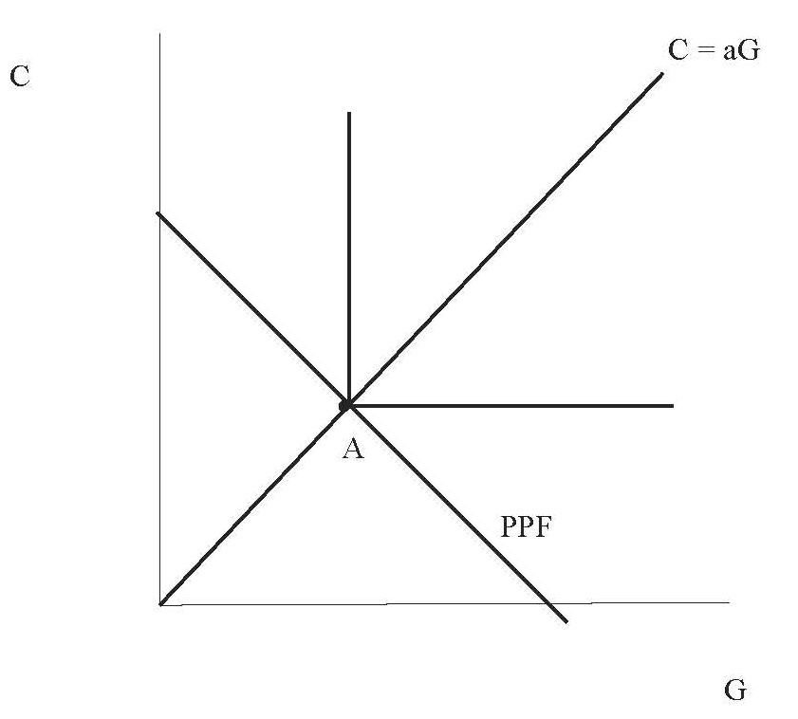
Figure 10.1

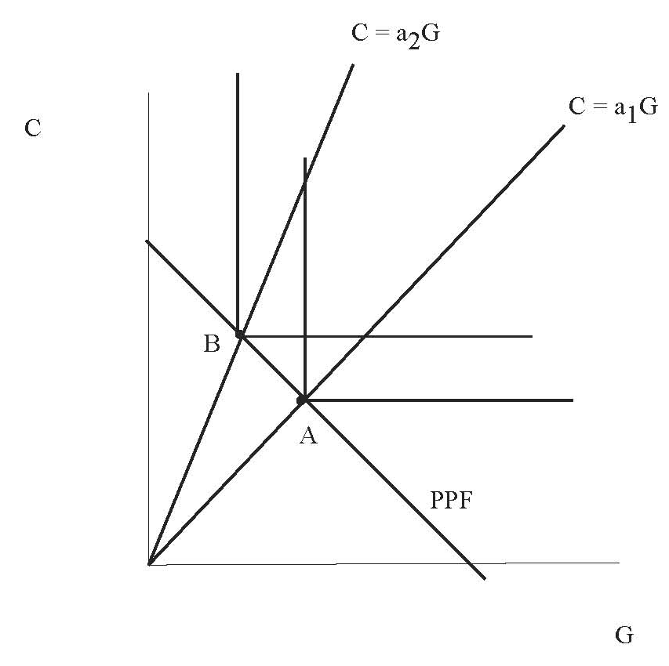
Figure 10.2

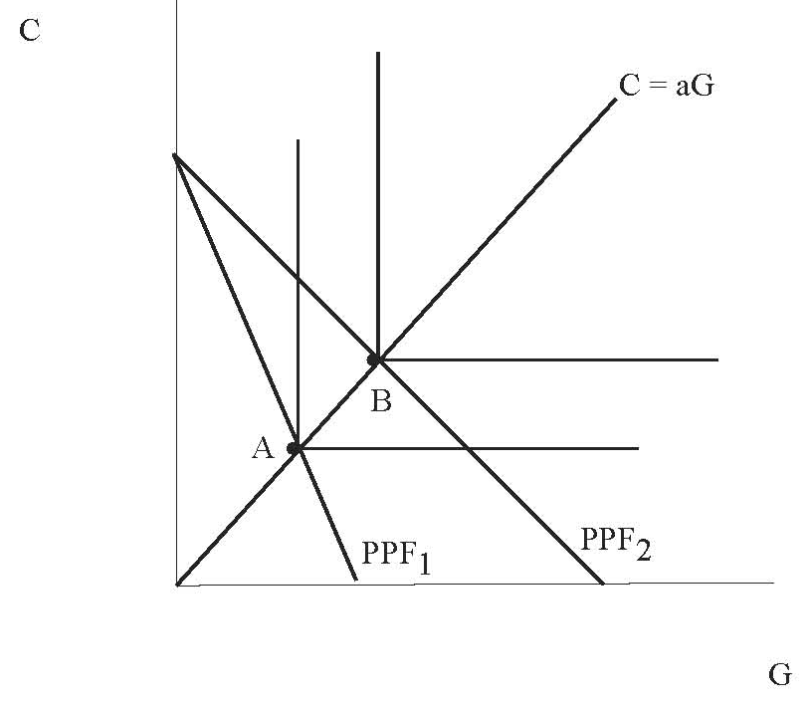
Figure 10.3

11. (a) If public goods and private goods are perfect substitutes, then the consumer always chooses C and l so that C = dl, and so given the production possibilities frontier, we must have
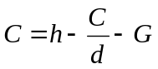
and so

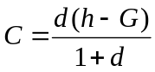

and

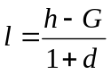

Therefore, consumption and leisure both decrease when government spending increases – a pure income effect.

(b) However, suppose that public goods and private goods are perfect complements. As in part (a), it is always optimal for the consumer to choose C and l so that C = dl. But the consumer faces a tax T = G, and the wage is w=1. So, if the consumer chooses the C = dl and the budget constraint is satisfied, then

and

,

just as in part (a). This is the only optimum if
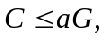

or

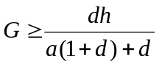

But, if

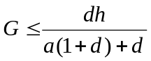

Then, it is optimal for the consumer to choose

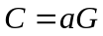

and

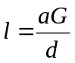.

In this case, the consumption bundle of the consumer actually lies inside the production possibilities frontier, and government spending has a Keynesian effect. More government spending implies greater consumption.

12. Since C = Y – T and G = T^{1/2}/a, therefore the production possibilities frontier can be expressed as C = Y – a²G². We can then depict this production possibilities frontier as PPF₁ in the figure:

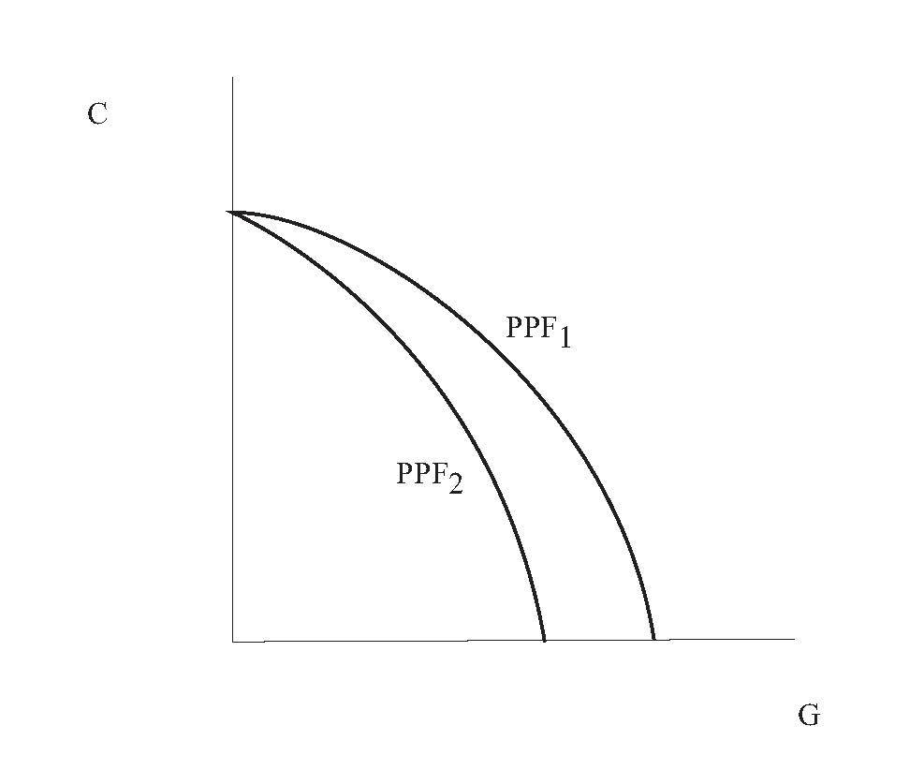

If a increases, this reduces the quantity of public goods that can be produced given the sacrifice of one unit of private consumption, so the production possibilities frontier shifts to PPF₂ in the figure. This requires an analysis incorporating income and substitution effects. For public goods, these effects work in the same direction, and public goods consumption must fall, but the effects work in opposite directions for private consumption, which could rise or fall. That is, the income effect is negative for both goods, but public goods have become relatively expensive, so there is substitution from public goods to private goods.

